1. 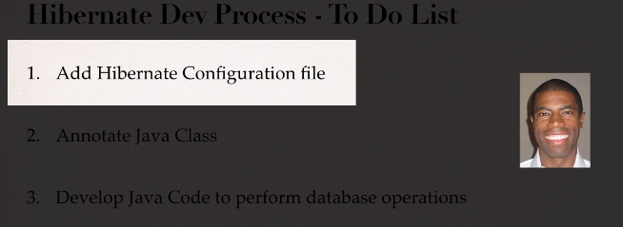
2. **Hibernate Configuration File**:
   1. Contains info about how to connect with DB. As Hibernate is based on JDBC so JDBC URL, UserId, Password. 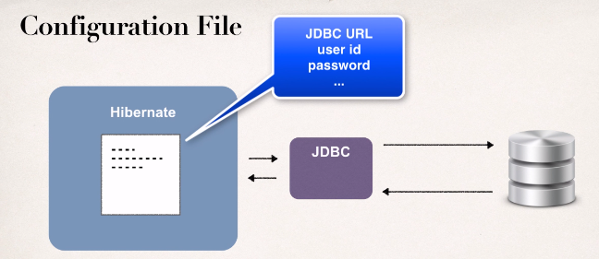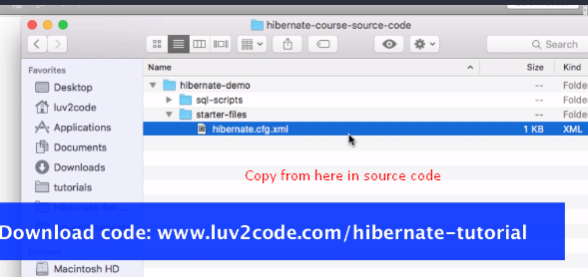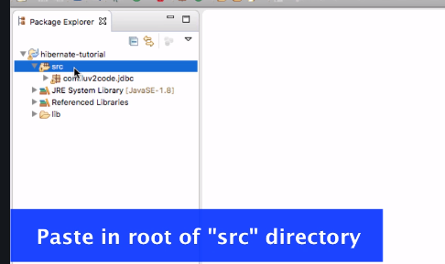
3. <**session-factory>**: It allows us to get session objects to connect with db.
4. Dialect: SQL is standard. However, each db has its own twist on it 🡺 dialect. So, here, we’re using Mysql Dialect.So when Hibernate generates SQL, it knows how to talk to MySQL. 